PGSuper Flexural Design Algorithm Modifications
Version 2.0, March 14, 2008

Change Log
3/14/2008 – rdp – Version 2.0
Added debond design. This work included reorganization of general flow charts, and addition of Appendix B – Debonding Perquisites.

12/14/2007 - R. Brice
-Designer not catching Mr < Mr Min at points other than mid-span.
-Design algorithm was implemented to only consider the mid-span point. I adjusted the algorithm to look at all flexural capacity analysis points.
-Designer was not converging on valid design.
-The case in question was during a compression controlled step in the strand sizing subsystem. The required concrete strength was computed, but was not updated because it was set to something larger by another design step. This indicates that there are way too many strands. I solved this by computing the concrete strength required to make the tension case work, this gets f’c in the ball park, and resetting the number of strands to the initial guess because they are way out of bounds. The design algorithm then restarts and converges on a design.

10/8/2007 – rdp Version 1.0
As-Is For Harped Design

Background
The flexural design algorithm in PGSuper is being modified so that it will be flexible enough to handle both TxDOT and WSDOT design requirements. The algorithm will also be modified to incorporate debond design as well as harped strand design. Note that shear design is not addressed in this document.

This document describes the user input and design algorithms required to make this change happen. Note that other changes have already been incorporated into the program to make this possible. One example is the new strand input UI/implementation.

Organization of This Document
The initial paragraphs of this document are meant to give the user an understanding of the background information for this project, and how the design algorithm will fit into the PGSuper program. However, the “meat” of the information is contained in the detailed flow charts contained in the Appendices. The flowcharts must be reviewed carefully to avoid major problems in the implementation. Apologies for the difficult reading, but in software development, the Devil hides in the details. Perquisite work required to add debonding design is defined in Appendix B. Also note that there is a Glossary of terms in Appendix C.

User Interface Changes
The following is a discussion of various user interface widgets that directly affect the design algorithm.

Girder Designer Dialog
The Preliminary Girder Designer dialog (shown below) will remain mostly unchanged. Design options are set in the Design Criteria library
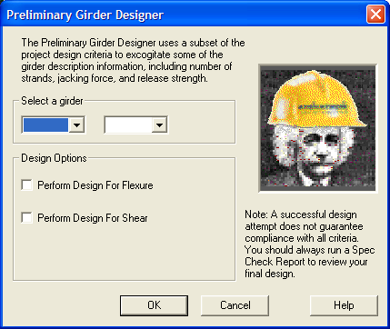

Design Criteria Dialog
Primary control of the design algorithm, and compliance checking is contained in a new tab to be added to the Design Criteria library entry. User’s wanting flexural design can now specify whether the algorithm will include the design of the “A” Dimension, Lifting, Hauling, Strand Slope, and Hold Down Force. Note that design cannot be turned on for an item unless compliance checking is also turned on.

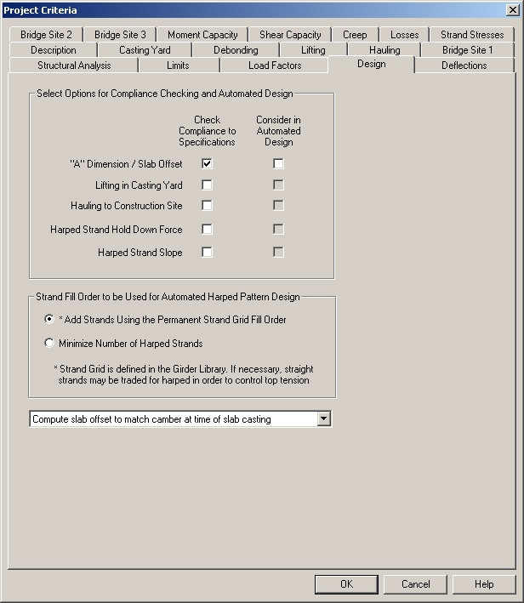

“A” Dimension Design
The “A” dimension is the vertical distance between the top of the slab and the top of the girder at the bearing line. If enabled, the “A” Dimension design will attempt to find a distance that will minimize “A” while keeping the girder from impinging into the slab at the highest camber location.

If “A” dimension design is disabled, the program will use the current project value.

Lifting Design
The lifting design algorithm will attempt to optimize values of lifting loop location, concrete strength, number of harped strands, and number of temporary strands so the girder can be safely lifted in the casting yard.

Hauling Design
The hauling design algorithm will attempt to optimize values of support locations, concrete strength, and number of temporary strands so the girder can be safely trucked from the casting yard to the construction site.

Strand Slope Design
Limiting max strand slope is a manufacturability requirement. If enabled, the algorithm will check to make sure the slope of harped strands is below the limit and will attempt to lower the harped pattern at the girder ends if it is.

Note that this option is only applicable to harped girder design.

Hold Down Force Design
Limiting max hold down force is a manufacturability requirement. If enabled, the algorithm will check to make sure the hold down force is below the limit and will lower the harped pattern at the girder ends if it is.

Note that this option is only applicable to harped girder design.

Fill Order for Harped and Straight Strand Design
This option tells the designer to either fill strands using the global strand order defined in the girder library entry, or to use a target proportion of straight to harped strands.

Changes to Other Design Criteria Tabs

Additional changes must also be made to the “Lifting”, “Hauling”, and “Casting Yard” tabs. When a criterion Check is disabled, all parameters will be disabled and, an informational message will be displayed to tell the user that the pertinent option has been turned off in the Design Options tab. As an example, the Lifting tab is shown below:

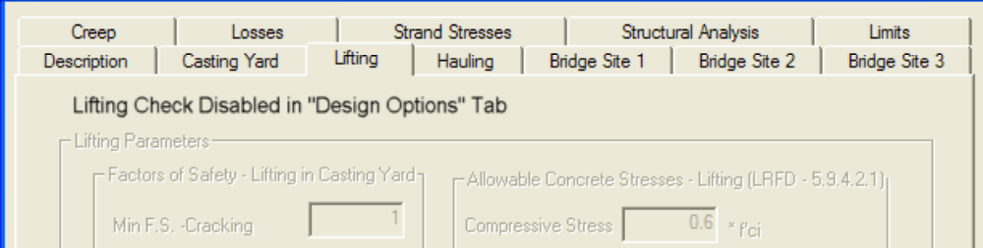

Other criterion will be treated similarly in their respective locations.

Girder Library Entry Dialog
The “Permanent Strands” tab in the Girder entry dialog shown below contains several parameters that directly affect the design algorithm. Note that changes required for Debond Design are defined in Appendix B.
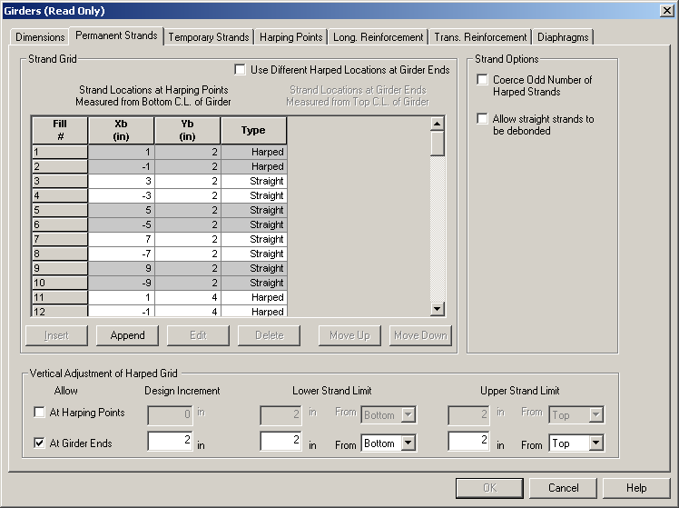

Strand Fill Order
The design algorithm fills strands using the strand order(s) defined on this tab. Straight and harped strands are filled independently if “Select Number of Strands Using Number of Harped and Number of Straight” is selected in the Girder Editor dialog (discussed later).

Strand Pattern Design
If harped strands exist, PGSuper will execute a harped pattern design. If only straight strands exist and “Allow straight strands to be debonded” is selected, a debond design will be done, otherwise a straight strands only design will be done.

Vertical Adjustment of Harped Strands
If harped strands exist, vertical adjustment of harped strand grids at the girder ends or harping points can be allowed, and the range of adjustment can be specified.

The design algorithm uses the design increment to vertically adjust strands. If the design increment is zero, the algorithm will not adjust the strands. However, users can manually adjust the strands in the Girder Editing dialog.

Questions/Open Issues
- Flowcharts for Lifting and Hauling are high-level and do not reflect all details in the implementation.

Description of the Appendices
The design algorithm flowcharts are in the following Appendices:

Appendix A – Flexural Design Flowcharts
The design flowcharts have been broken into four logical sections:
- Overall driving logic of design
- Common remedies to all prestressed girders
- Remedies for harped design
- Remidies for debond design

Appendix B – Prerequisites for Debond Design

Appendix C – Glossary of Terms
Appendix C – Glossary of Terms

